# Vasu Bansal

# 20BCE1072

# CSE4003

# PBL-2

# Final Demo:

The front-end for the application that we have made which consists of:

1. Home Page (index.html)
2. Malware Detected Page (yes.html)
3. Malware Not DetectedPage (pg2.html)

The flow of the code goes something like this - The python code is kept running live using ‘uvicorn’, which is an ASGI (Asynchronous Server Gateway Interface) server implementation for Python. The user accesses the home page and uploads the file they feel requires some checking.The file is passed onto the backend and  Python functions in the backend predict whether the given file contains a virus or not. If the uploaded file has a risk of having a virus, the user is suggested some remedies on how to check if their PC has been damaged. If not, they get a green light on opening and using the file.

**1. Home Page:**

<!DOCTYPE html>

<html>

<head>

    <link href="{{ url_for('static', path='/cybsec.css') }}" rel="stylesheet">

    <script src="//cdnjs.cloudflare.com/ajax/libs/jquery/2.1.3/jquery.min.js"></script>

    <script src="https://www.mattboldt.com/demos/typed-js/js/typed.custom.js"></script>

    <script src="https://cdn.jsdelivr.net/particles.js/2.0.0/particles.min.js"></script>

    <script src="https://cdnjs.cloudflare.com/ajax/libs/animejs/3.2.0/anime.min.js"></script>

</head>

<body>

    <div id="particles-js"></div>

    <div class="terminal-window">

        <header>

            <div class="button green"></div>

            <div class="button yellow"></div>

            <div class="button red"></div>

        </header>

        <section class="terminal">

            <div class="history"></div>

            $&nbsp;<span class="prompt"></span>

            <span class="typed-cursor"></span>

        </section>

    </div>

    <form method="POST" action="/predict" enctype="multipart/form-data">

        <div class="file-upload">

            <div class="file-upload-select">

                <div class="file-select-button">Choose File</div>

                <div class="file-select-name">No file chosen...</div>

                <input type="file" name="file" id="file-upload-input">

            </div>

            <div>

                <input type="submit" value="Upload">

            </div>

        </div>

    </form>

    <script src="{{url_for('static', path='/cybsec.js')}}"></script>

    <script>

        const data = await res.text();

        document.body.appendChild(document.createTextNode(data))

    </script>

</body>

</html>

**2. Malware Detected Page:**

<html>

<head>

    <title>Ultimate Prediction</title>

    <link rel="stylesheet" href="{{ url_for('static', path='/yes.css') }}">

    <script src="//cdnjs.cloudflare.com/ajax/libs/jquery/2.1.3/jquery.min.js"></script>

    <script src="https://www.mattboldt.com/demos/typed-js/js/typed.custom.js"></script>

    <script src="https://cdn.jsdelivr.net/particles.js/2.0.0/particles.min.js"></script>

    <script src="https://cdnjs.cloudflare.com/ajax/libs/animejs/3.2.0/anime.min.js"></script>

</head>

<div id="particles-js"></div>

<div class="terminal-window">

    <header>

        <div class="button green"></div>

        <div class="button yellow"></div>

        <div class="button red"></div>

    </header>

    <section class="terminal">

        <div class="history"></div>

        $&nbsp;<span class="prompt"></span>

        <span class="typed-cursor"></span>

    </section>

</div>

<!-- data -->

<script src="{{ url_for('static', path='/yes.js') }}"></script>

</div>

</html>

**3. Malware Not Detected Page (pg2.html)**

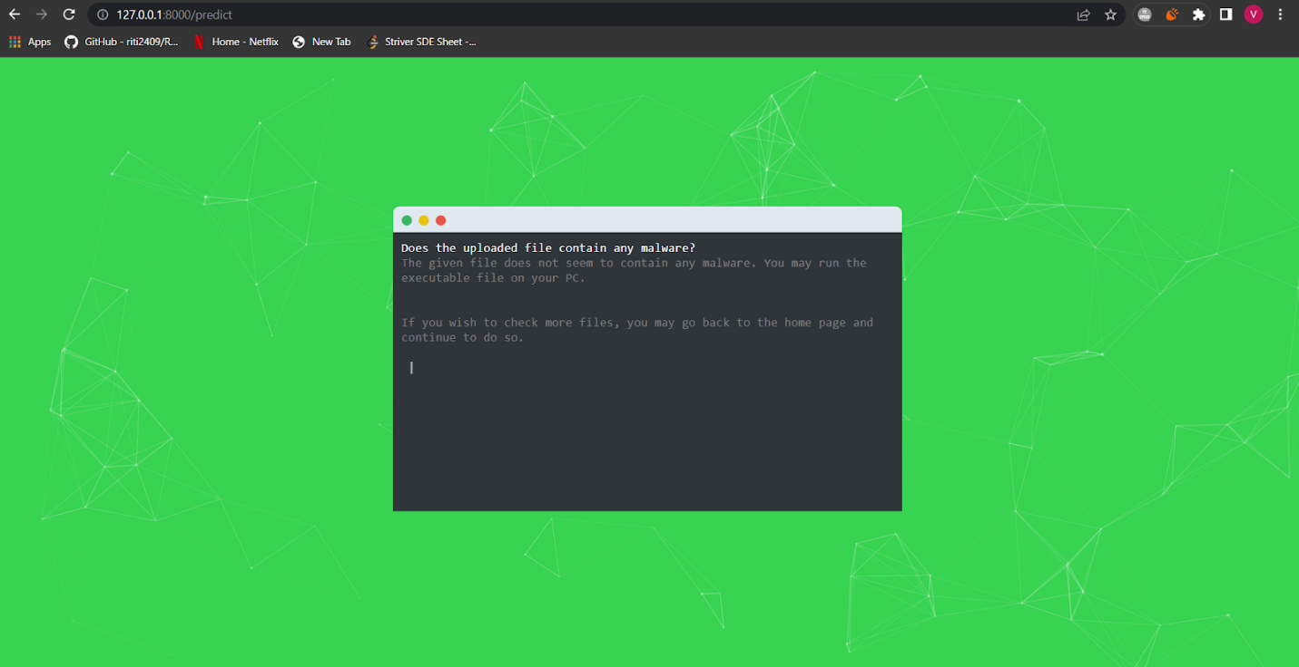

<html>

<head>

    <title>Ultimate Prediction</title>

    <link rel="stylesheet" href="{{ url_for('static', path='/pg2.css') }}">

    <script src="//cdnjs.cloudflare.com/ajax/libs/jquery/2.1.3/jquery.min.js"></script>

    <script src="https://www.mattboldt.com/demos/typed-js/js/typed.custom.js"></script>

    <script src="https://cdn.jsdelivr.net/particles.js/2.0.0/particles.min.js"></script>

    <script src="https://cdnjs.cloudflare.com/ajax/libs/animejs/3.2.0/anime.min.js"></script>

</head>

<div id="particles-js"></div>

<div class="terminal-window">

    <header>

        <div class="button green"></div>

        <div class="button yellow"></div>

        <div class="button red"></div>

    </header>

    <section class="terminal">

        <div class="history"></div>

        &nbsp;<span class="prompt"></span>

        <span class="typed-cursor"></span>

    </section>

</div>

<!-- data -->

<script src="{{ url_for('static', path='/pg2.js') }}"></script>

</div>

</html>